Creating your First PowerShell Script using
PowerShell Core SOP



Table of Contents

1. Creating your First PowerShell Script using PowerShell Core 3
1.1 Description 3
1.2 Architecture Diagram 3
1.3 Lab Steps 4
1.4 Troubleshooting 5
1.5 Supporting References 5

Creating your First PowerShell Script using PowerShell Core

Description
In this lab exercise, you will create a PowerShell script in a Virtual Machine that outputs process information to a file. You will have to use the appropriate PowerShell commands to filter the processes according to some parameters.

Architecture Diagram
The diagram below displays a visual representation of the application architecture:
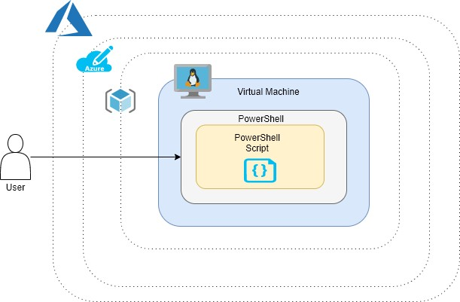

Lab Steps
Follow the steps outlined below to achieve the objective of this lab exercise:

- Create a Linux Virtual Machine:
  - Go to the Azure Portal, click on Create a resource > Ubuntu Server 18.04 LTS b. Provide below details:
    - Resource Group: Your Resource Group name
    - Virtual Machine Name: <any-unique-name>
    - Region: Any (In case of any error, go as per the lab policy)
    - Image: Ubuntu Server 18.04 LTS-Gen1
    - Size: Standard_B1s
    - Authentication Type: Password
    - Give a username and password.
    - Leave other field as is and go to Management Tab.
    - Select Boot Diagnostics to Off
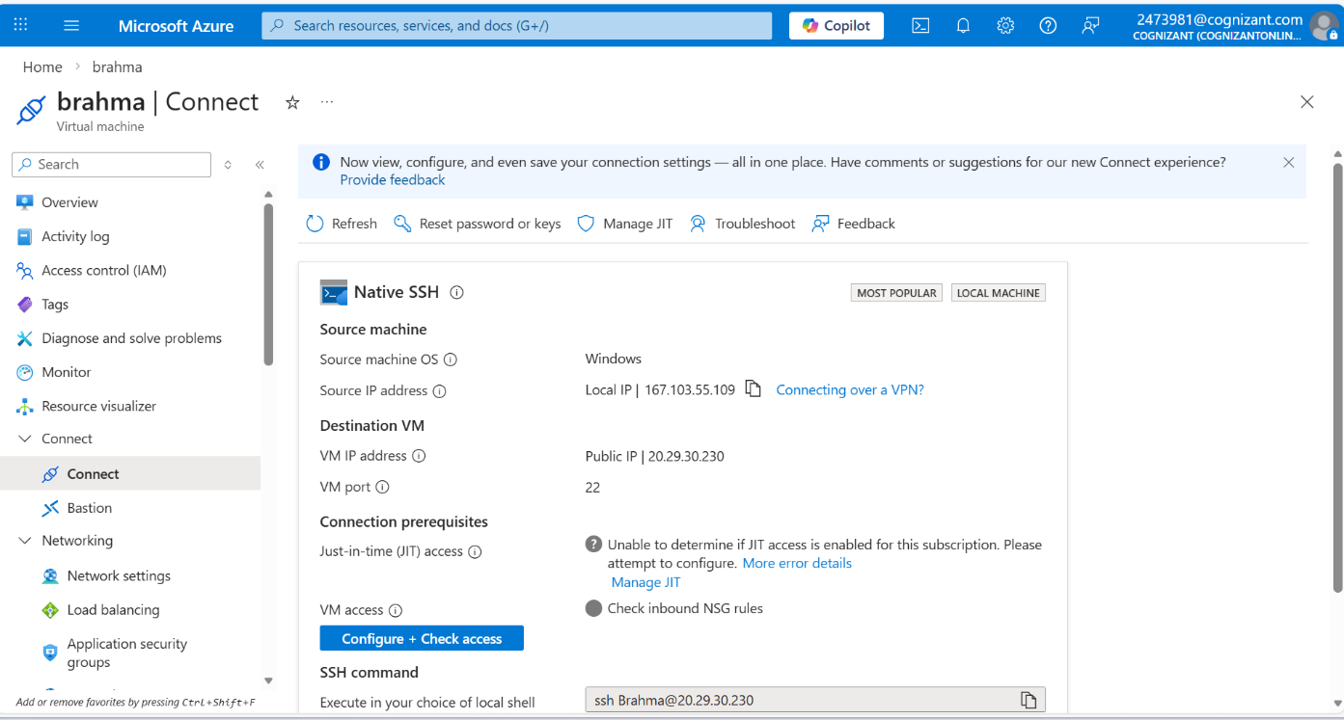
    - Leave other fields with their default values and click on Review+Create > Create.

- Install PowerShell:
  - Connect to your Linux Virtual Machine with the following command:
ssh username@<publicIPofVM>
  - Install PowerShell module in Linux VM:
sudo snap install powershell --classic
  - Once the installation is complete, launch the PowerShell prompt:
pwsh
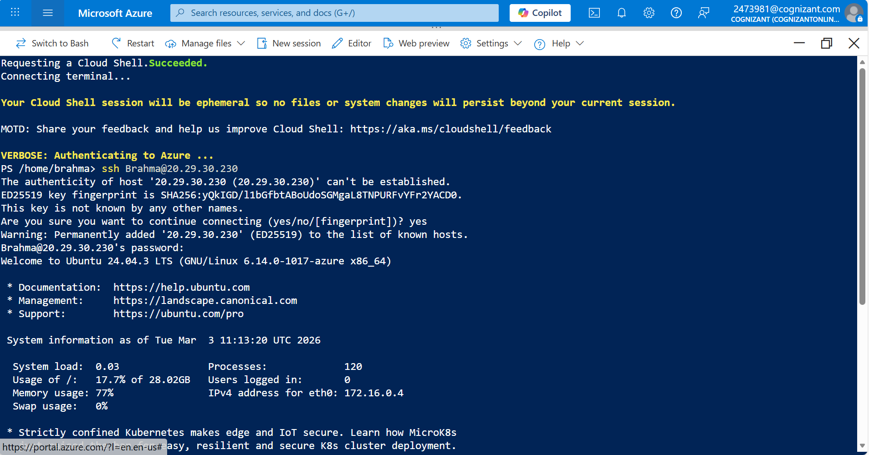
- Create the PowerShell Script:
  - Collate all the commands which you want to put in your script.
  - The following command will give all the processes on your machine and store it in a variable:
$ps = Get-Process
  - Use pipelines to pass the output of Get-Process and only take the WorkingSet and ProcessName object type.
$ps = Get-Process | Select-Object WorkingSet,ProcessName
  - Use pipelines again to pass the output to Format-Table:
$ps = Get-Process | Select-Object WorkingSet,ProcessName | FormatTable
  - Use Pipeline last time, to store all this output in a csv file:
$ps = Get-Process | Select-Object WorkingSet,ProcessName | Format-
Table | Out-File processinfo.csv

  - Create a file by using the following command:
vi processinfo.ps1
  - Put the code defined in step 3e in this file and then save the file by entering: wq!
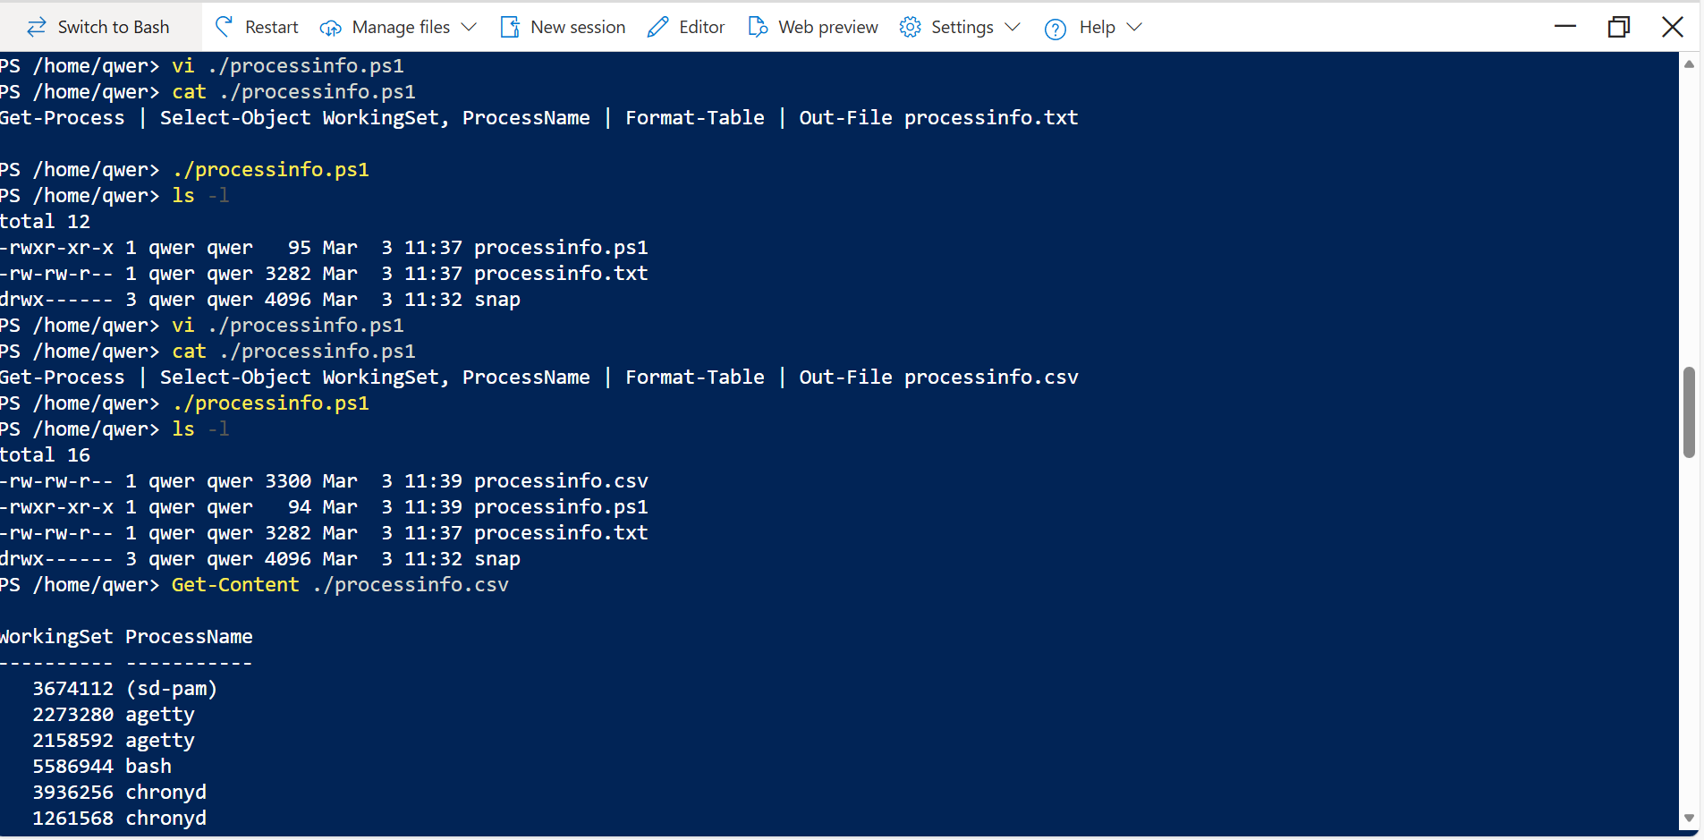

- Run the script:
  - Make sure that you are in PowerShell prompt.
  - Run the PowerShell script by typing ./processinfo.ps1 from the same directory as the file.
  - A processinfo.csv will be generated in the same directory.
  - Open the file using the following command:
Get-Content ./processinfo.csv

- Clean up resources:
  - When you are done with your lab exercise, delete all the resources created by you.

Troubleshooting
S. No | Problem | Solution
1 | Not able to select desired Region | Go as per the Lab Policy, look for any error and suggested options to be followed.
2 | Permission Denied | Use the command with sudo privileges.

Supporting References
Refer the below links for additional information:

- https://docs.microsoft.com/en-us/powershell/scripting/install/installing-powershell-core-onlinux?view=powershell-7
- https://4sysops.com/archives/creating-powershell-core-scripts-on-linux/

